Smarty Weather Station
Final Project Documentation For ELET2415 Submission
Prepared date: April 21, 2026
ESP32 weather and soil monitoring system with Flask, MongoDB, and Vue dashboard

Prepared for ELET2415 project submission
Prepared date: April 21, 2026
Project folder: ELET2415/Project

Document Control
Item | Detail
Project name | Smarty Weather Station
System type | ESP32 IoT weather and soil monitoring station
Main hardware | ESP32 sensor board, ESP32-2432S028 touch gateway board, DHT22, BMP280, capacitive soil sensor
Main software | Arduino firmware, Flask backend, MongoDB, Vue/Vuetify frontend
Main communication path | Sensors -> ESP32 sensor node -> ESP-NOW -> ESP32 display/gateway -> Wi-Fi HTTP -> Flask -> MongoDB -> Vue dashboard
Primary source folders | hardware/, backend/, frontend/, presentation/assets/images/, Project Documentation/
Submission document | This final consolidated documentation file
Git repository | https://github.com/RICK-MONK/Weather-Station

Table Of Contents
- Executive Summary
- Project Background And Objectives
- Requirements And Scope
- System Architecture
- Bill Of Materials
- Component List
- Hardware Design
- Schematics And Wiring Diagrams
- Firmware Design
- Backend Work
- Frontend Work
- Data Model And API Reference
- Software And Hardware Diagrams
- Setup And Operation
- Testing And Validation
- Results And Project Evidence
- Troubleshooting, Risks, And Limitations
- Future Improvements
- Conclusion
- Appendices

1. Executive Summary
Smarty Weather Station is an end-to-end IoT environmental monitoring project. It measures weather and soil conditions using ESP32-based hardware, sends readings wirelessly, stores data in a backend database, and displays live and historical readings through a web dashboard.
The project is more than a single-sensor serial monitor demonstration. It combines embedded firmware, sensor validation, ESP-NOW wireless transfer, local TFT display output, Flask API development, MongoDB storage, MQTT publishing support, and a Vue/Vuetify frontend. The final system gives the user both local visibility on the display node and remote visibility through a browser.
The system measures:
- temperature
- relative humidity
- heat index
- atmospheric pressure
- estimated altitude derived from pressure
- soil moisture as a calibrated relative percentage
The strongest engineering features are the system separation between sensor and gateway boards, validation of sensor readings, moving-average smoothing, last-valid-sample fallback behavior, backend timestamping, historical storage, dashboard trend views, and sensor-health flags.

2. Project Background And Objectives
Environmental monitoring is useful in agriculture, greenhouses, classrooms, laboratories, and smart-site monitoring. Many low-cost student sensor projects only display values locally or through the serial monitor. That makes the project useful for a proof of concept, but weak as a complete monitoring system.
This project addresses that gap by building a full sensing-to-dashboard pipeline. The goal is to collect data from multiple sensors, validate the data, move it wirelessly, store it centrally, and present it in a way that a user can understand.

2.1 Problem Statement
Environmental data is only useful if it can be trusted, accessed, and interpreted. A practical weather station must handle noisy readings, temporary sensor failure, wireless communication issues, backend storage, and user-facing visualization.

2.2 Project Objectives
- Measure temperature and humidity with a DHT22 sensor.
- Measure atmospheric pressure with a BMP280 sensor.
- Estimate altitude from BMP280 pressure and a sea-level pressure reference.
- Measure soil moisture using an analog soil moisture sensor.
- Transfer readings between boards using ESP-NOW.
- Forward readings to a Flask backend over Wi-Fi using HTTP.
- Store readings in MongoDB with server-side timestamps.
- Display live readings locally on a TFT display.
- Display live, recent, and analyzed readings in a Vue dashboard.
- Expose backend status and control actions through a frontend control page.

3. Requirements And Scope

3.1 Functional Requirements
Requirement | Implementation
Collect temperature | DHT22 connected to ESP32 sensor node
Collect humidity | DHT22 connected to ESP32 sensor node
Calculate heat index | Firmware computes heat index from temperature and humidity
Collect pressure | BMP280 connected by I2C
Estimate altitude | Firmware derives altitude from pressure using SEA_LEVEL_PRESSURE_HPA
Collect soil moisture | Analog soil sensor connected to ADC GPIO
Transfer data locally | ESP-NOW packet from sensor node to display/gateway node
Display local readings | TFT display on gateway board
Forward to backend | HTTP POST to /api/weather/update
Store history | MongoDB collection configured by backend environment
Show dashboard | Vue/Vuetify frontend with dashboard, live, control, and analysis pages
Analyze data | Backend returns min, max, average, samples, and recent rows

3.2 Non-Functional Requirements
- The system should continue operating when one sensor temporarily fails.
- The dashboard should report stale or delayed data rather than silently hiding it.
- The backend should validate incoming data before storage.
- Sensor data should be stored with consistent backend timestamps.
- The frontend should support metric and imperial display modes.

3.3 In Scope
- ESP32 firmware for sensing and display/gateway operation.
- Weather payload validation and storage.
- Live dashboard views.
- Recent-history queries.
- Date-range analysis queries.
- Backend-tracked control actions.
- Project schematics, wiring references, dashboard screenshots, and visual evidence from the project folder.

3.4 Out Of Scope For The Current Repository
- User authentication.
- Secure device provisioning.
- Weatherproof enclosure.
- Battery or solar power management.
- Device-side execution of backend queued commands.
- Formal automated regression test suite.

4. System Architecture
The project uses a layered IoT architecture:
- sensing layer
- local wireless transport layer
- gateway and display layer
- backend storage and API layer
- browser dashboard layer

4.1 High-Level Architecture Diagram
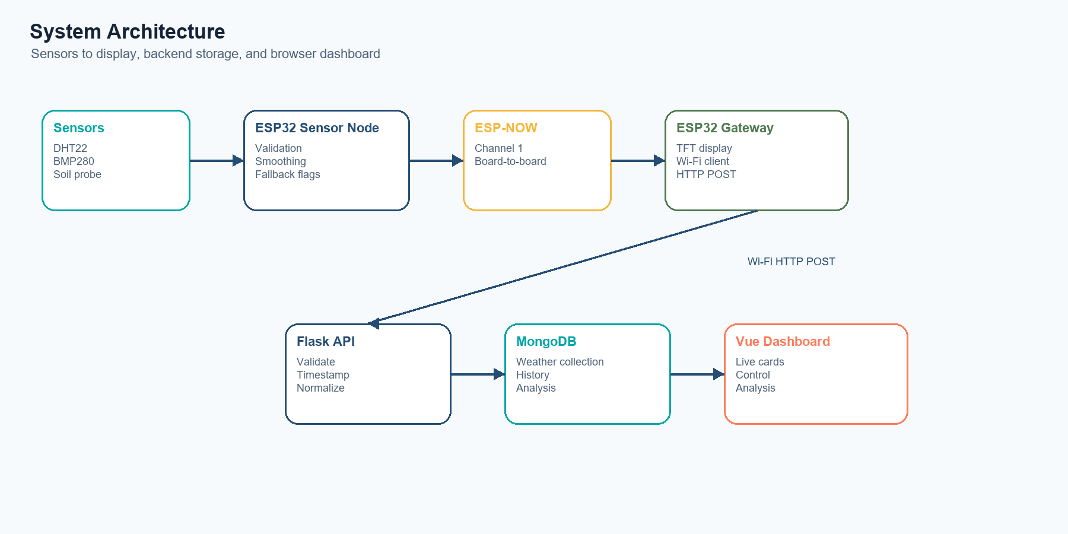
Generated system architecture diagram
flowchart LR
DHT[DHT22 temperature and humidity]
BMP[BMP280 pressure]
SOIL[Soil moisture sensor]
SENSOR[ESP32 sensor node]
ESPNOW[ESP-NOW wireless link]
GATEWAY[ESP32 display and gateway]
WIFI[Wi-Fi and HTTP]
API[Flask API]
DB[MongoDB]
UI[Vue dashboard]
DHT --> SENSOR
BMP --> SENSOR
SOIL --> SENSOR
SENSOR --> ESPNOW
ESPNOW --> GATEWAY
GATEWAY --> WIFI
WIFI --> API
API --> DB
API --> UI
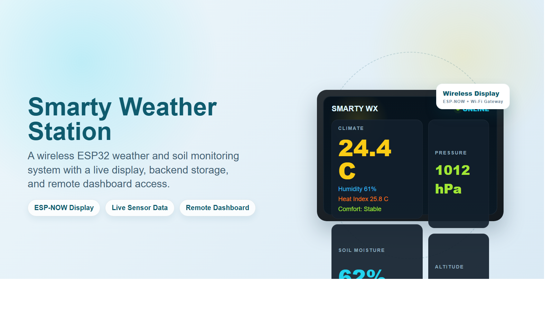
Wireless weather station overview

4.2 End-To-End Data Flow
- The sensor ESP32 reads the DHT22, BMP280, and soil sensor.
- Firmware validates readings and rejects values outside expected ranges.
- Firmware smooths accepted values using a moving average.
- Firmware creates a SensorData payload.
- The sensor node sends the payload to the gateway node through ESP-NOW.
- The gateway displays readings on the TFT screen.
- The gateway posts JSON to the Flask backend.
- The Flask backend validates and normalizes the payload.
- The backend stores the reading in MongoDB and attempts MQTT publishing.
- The Vue frontend polls backend routes and updates dashboards, charts, and analysis views.

4.3 Communication Paths
Source | Destination | Protocol | Purpose
Sensor node | Display/gateway node | ESP-NOW | Low-overhead local wireless data transfer
Gateway node | Flask backend | HTTP POST over Wi-Fi | Store latest reading
Frontend | Flask backend | HTTP GET/POST | Retrieve data and submit control actions
Backend | MQTT broker | MQTT publish | Optional secondary publish path after database save

4.4 Active Operating Modes
Mode | Description | Repository path
PCB split system | Main submission architecture: sensor board sends ESP-NOW packets to display/gateway board | hardware/active/pcb_sensor_test/pcb_sensor_project/ and hardware/active/pcb_display_project/
Generic ESP-NOW split system | General two-board sender/gateway sketches | hardware/active/espnow_weather/
Standalone firmware path | Single-folder weather station firmware path | hardware/active/weather_station/
Direct Wi-Fi sensor mode | Sensor can post directly to backend when configured | SENSOR_TRANSPORT_DIRECT_WIFI compile-time flag

For the current PCB sensor sketch, SENSOR_TRANSPORT_DIRECT_WIFI is set to 0, so the active PCB path uses ESP-NOW to the display/gateway board.
The bill of materials below includes estimated hardware costs in USD based on representative online pricing checked on April 24, 2026. These figures are estimates for documentation purposes and exclude shipping and tax.
No purchase receipts or confirmed pricing data were found in the project folder. The bill of materials below therefore lists the confirmed hardware quantity, purpose, and interface based on the sketches, documentation, and schematic images in the repository.
Item | Quantity | Estimated cost (USD) | Purpose | Interface / Notes
ESP32 development board (sensor node) | 1 | 7.69 | Sensing and packet transmission | Wi-Fi, ESP-NOW, GPIO, ADC, I2C
ESP32-2432S028 touch display/gateway board | 1 | 13.99 | Local display, touch UI, and backend forwarding | Integrated ESP32 and touch TFT used by the gateway firmware
DHT22 temperature and humidity sensor | 1 | 8.90 | Measures ambient temperature and relative humidity | Digital signal on GPIO 4
BMP280 pressure sensor module | 1 | 9.95 | Measures pressure and supports derived altitude estimate | I2C on GPIO 21 SDA and GPIO 22 SCL
Capacitive soil moisture sensor | 1 | 5.90 | Measures relative soil moisture | ADC input on GPIO 34
USB power leads and small support parts | 1 set | 5.90 | Board power and basic hookup support | Includes USB leads used for programming and demonstration power
Wiring, headers, and connectors | 1 set | 3.95 | Sensor and board interconnection | Required for assembly and bench testing
Prototype breadboard hardware | 1 set | 4.95 | Temporary assembly and integration | Breadboard or equivalent prototyping hardware
Estimated hardware total | - | 61.23 | Estimated total before shipping and tax | Representative online prices checked April 24, 2026

6. Component List

6.1 ESP32 Sensor Node
Role:
- reads the DHT22, BMP280, and soil sensor
- validates and smooths readings
- builds the SensorData payload
- sends payload through ESP-NOW in the current PCB configuration
Key firmware file:
- hardware/active/pcb_sensor_test/pcb_sensor_project/pcb_sensor_project.ino

6.2 ESP32 Display And Gateway Node
Role:
- receives ESP-NOW packets
- displays live values on the TFT
- evaluates freshness and warning states
- connects to Wi-Fi
- posts weather JSON to Flask
Key firmware file:
- hardware/active/pcb_display_project/pcb_display_project.ino

6.3 DHT22 Sensor
Measurements:
- temperature in degrees Celsius
- relative humidity in percent
Used for:
- ambient temperature display
- humidity display
- computed heat index

6.4 BMP280 Sensor
Measurements:
- atmospheric pressure in hPa
Derived value:
- estimated altitude in meters
Important interpretation:
- altitude is calculated from pressure and the configured sea-level reference
- it should not be presented as a directly measured GPS-style altitude

6.5 Soil Moisture Sensor
Measurements:
- raw ADC value
- calibrated relative moisture percentage
Important interpretation:
- the percentage is relative to the firmware calibration constants
- it is not an absolute volumetric water-content measurement

6.6 TFT Display
Purpose:
- local visualization without requiring a browser
- displays weather, soil, system, and connection status screens in the gateway sketch
Current PCB note:
- the PCB display sketch initializes touch-related constants but disables touch navigation with initializeTouchNavigation()

7. Hardware Design

7.1 Hardware Overview
The hardware design separates sensing from display and networking. The sensor node can be positioned near the measurement area, while the gateway node can be positioned where it can display data and reach the backend network.
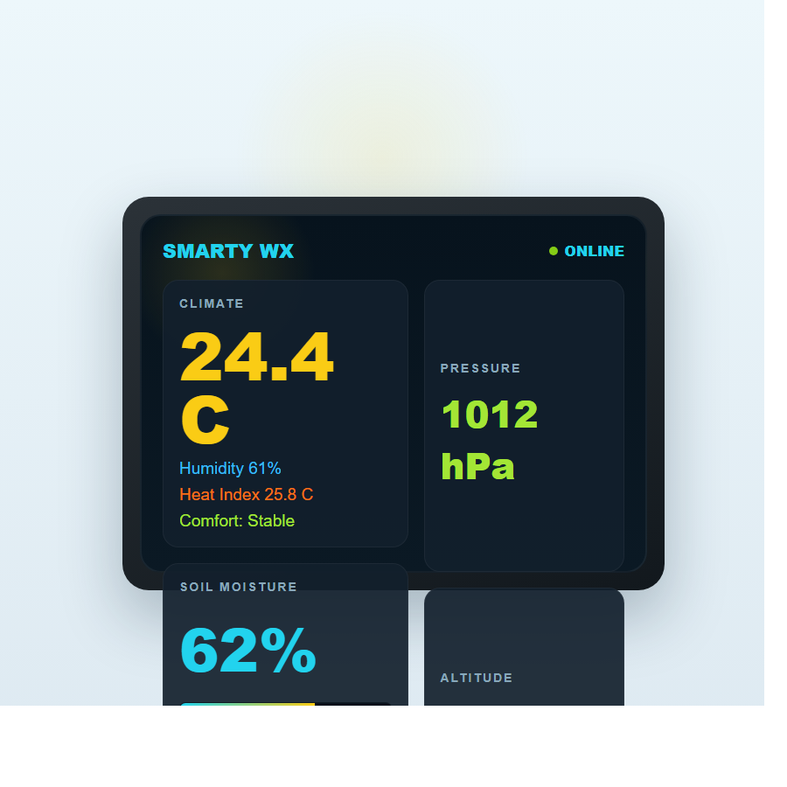
ESP32 weather station device visual

7.2 Sensor PCB Pin Mapping
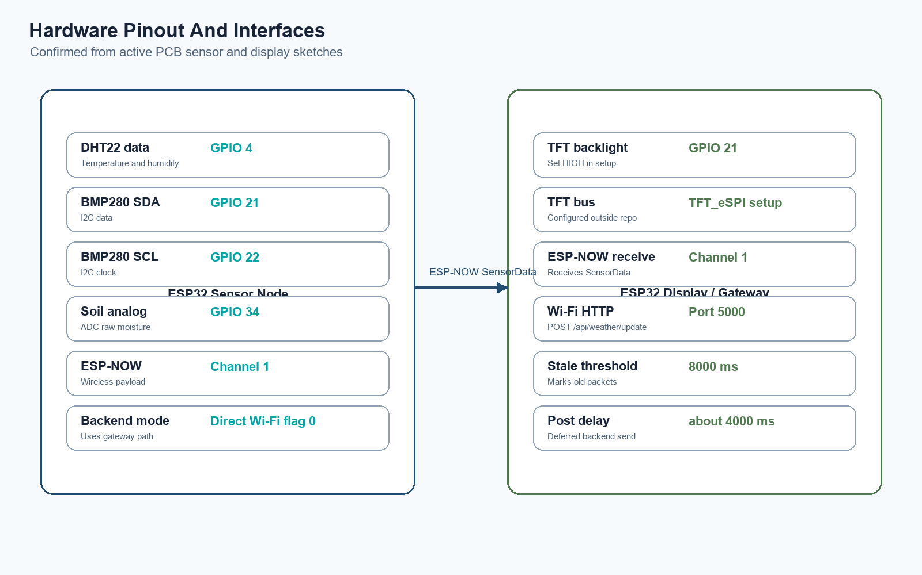
Generated hardware pinout diagram
Signal | ESP32 GPIO | Interface | Purpose
DHT22 data | 4 | Digital | Temperature and humidity
BMP280 SDA | 21 | I2C data | Pressure sensor data
BMP280 SCL | 22 | I2C clock | Pressure sensor clock
Soil sensor analog output | 34 | ADC | Soil moisture raw value

7.3 Display/Gateway Known Signals
Signal | ESP32 GPIO / Setting | Purpose
TFT backlight | GPIO 21 | Backlight enabled high in setup
ESP-NOW channel | 1 | Must align with sender channel
Backend port | 5000 | Flask API port
Project location label | Project Site | Display header metadata
NTP servers | pool.ntp.org, time.nist.gov | Gateway clock sync

Additional TFT bus pin assignments are controlled by the local TFT_eSPI setup outside this repository.

7.4 Firmware Calibration Constants
Constant | Value | Meaning
SOIL_RAW_DRY | 720 | Dry-side soil calibration reference
SOIL_RAW_WET | 160 | Wet-side soil calibration reference
SOIL_SAMPLE_COUNT | 10 | Soil ADC samples averaged per read
SMOOTHING_WINDOW | 3 | Moving-average sample count
SEA_LEVEL_PRESSURE_HPA | 1013.25 | Pressure reference for estimated altitude
ESPNOW_WIFI_CHANNEL | 1 | ESP-NOW channel used by sensor and gateway
DHT_MAX_READ_RETRIES | 2 | DHT retry count
BMP280_MAX_READ_RETRIES | 3 | BMP retry count

7.5 Sensor Range Validation
Sensor / Field | Firmware validation
Temperature | -40 to 80 degrees Celsius
Humidity | 0 to 100 percent
Pressure | 300 to 1100 hPa
Estimated altitude | -150 to 4000 m
Soil raw ADC | 50 to 4000

8. Schematics And Wiring Diagrams

8.1 Project Schematic Reference
The schematic reference in the project folder shows an ESP32 weather station design with power regulation, indicator LEDs, programming header, sensor inputs, and ESP32 module connections.
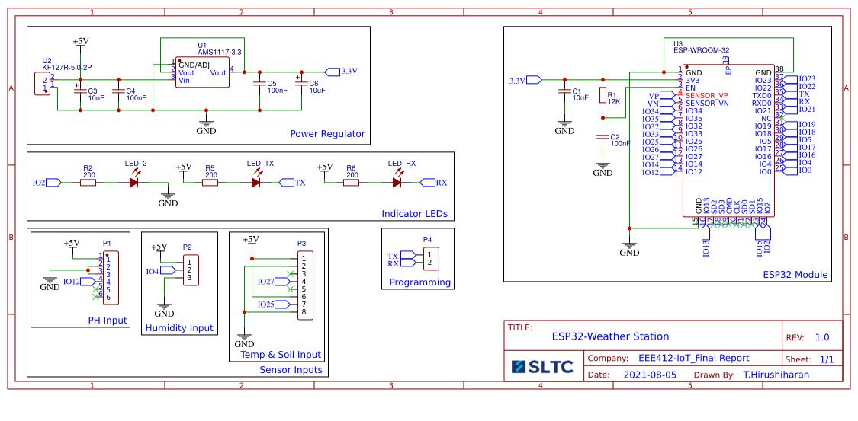
Weather station schematic
Key schematic blocks:
- power regulator from 5 V to 3.3 V
- indicator LEDs
- programming pins
- humidity input
- temperature and soil input
- ESP32 module

8.2 Sensor Wiring Reference
The project includes wiring references for DHT22, BMP280, and soil sensor connections to an ESP32.
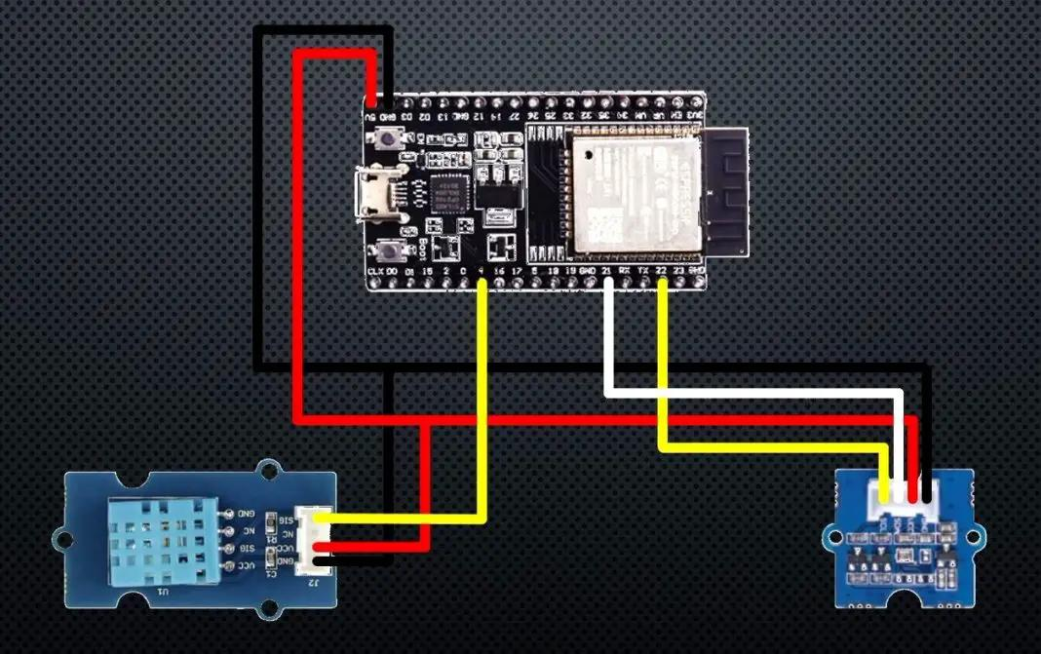
ESP32 DHT22 and BMP280 wiring
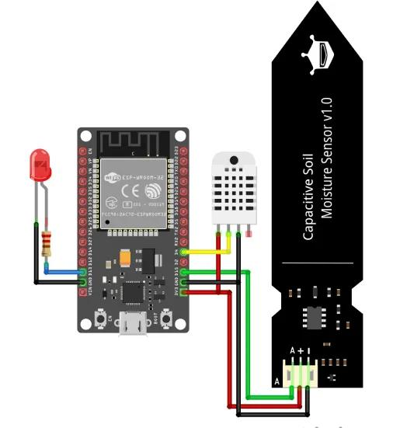
ESP32 soil and DHT wiring

8.3 Wireless Link Diagram
The wireless design separates the sensor node and the display/gateway node.
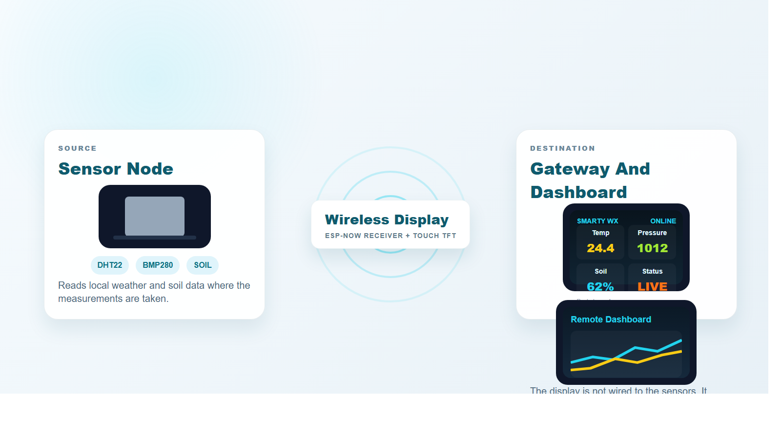
Wireless link concept

8.4 Hardware Block Diagram
+------------------+ ESP-NOW +------------------------+
| ESP32 Sensor PCB | -------------------> | ESP32 Display Gateway |
| | | |
| DHT22 | | TFT display |
| BMP280 | | Wi-Fi client |
| Soil sensor | | HTTP POST client |
+------------------+ +-----------+------------+
|
| Wi-Fi HTTP
v
+--------+---------+
| Flask Backend |
| MongoDB Storage |
+--------+---------+
|
v
+--------+---------+
| Vue Dashboard |
+------------------+

9. Firmware Design
The firmware is divided across the sensor node and display/gateway node.
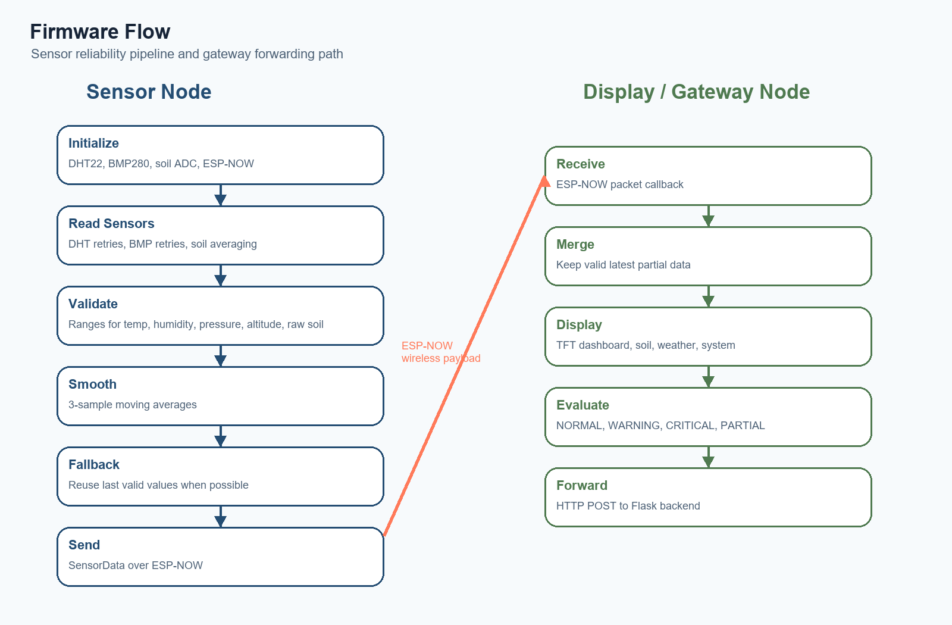
Generated firmware flow diagram

9.1 Firmware Source Files
Firmware path | Purpose
hardware/active/pcb_sensor_test/pcb_sensor_project/pcb_sensor_project.ino | Current PCB sensor-node sketch
hardware/active/pcb_display_project/pcb_display_project.ino | Current PCB display/gateway sketch
hardware/active/espnow_weather/sensor_espnow_weather_sender/sensor_espnow_weather_sender.ino | Generic split sensor sender
hardware/active/espnow_weather/display_espnow_weather_gateway/display_espnow_weather_gateway.ino | Generic split display/gateway
hardware/active/weather_station/weather_station.ino | Standalone weather-station sketch

9.2 Sensor Node Responsibilities
- initialize DHT22, BMP280, soil ADC, Wi-Fi station mode, and ESP-NOW
- read all sensors on a repeated loop
- validate sensor values against safe ranges
- retry DHT22 and BMP280 reads
- average soil ADC samples
- smooth accepted values using a 3-sample moving average
- keep last-valid values when sensors fail temporarily
- compute heat index
- convert soil raw values to relative moisture percentage
- send a SensorData struct every loop cycle

9.3 Sensor Startup Flow
Start serial logging
Initialize DHT22
Initialize I2C for BMP280
Initialize soil ADC
Try BMP280 address 0x76, then 0x77
Set Wi-Fi station mode
Set ESP-NOW channel
Print sender MAC and gateway MAC
Initialize ESP-NOW
Register gateway peer
Begin repeated sensing loop

9.4 SensorData Payload
Field | Type | Meaning
temperature | float | DHT22 temperature
humidity | float | DHT22 relative humidity
heatIndex | float | Calculated heat index
pressure | float | BMP280 pressure in hPa
altitude | float | Pressure-derived altitude estimate
seaLevelPressureHpa | float | Reference pressure used for altitude
soilMoisture | int | Raw soil ADC value inside the ESP-NOW struct
altitudeEstimated | uint8_t | Indicates estimated altitude field
dhtOk | uint8_t | DHT read health flag
bmpOk | uint8_t | BMP read health flag
soilOk | uint8_t | Soil read health flag
sampleMillis | uint32_t | Device millis() sample time

Backend JSON also includes:
- soilRaw
- soilMoisturePercent
- backend-generated timestamp

9.5 Gateway Firmware Responsibilities
- initialize TFT display and backlight
- connect to Wi-Fi
- request NTP clock sync
- initialize ESP-NOW receive mode
- receive SensorData packets
- merge partial incoming readings with previous readings
- draw dashboard, soil, weather, and system screens
- detect stale packets after 8000 ms
- post JSON payloads to Flask approximately 4000 ms after packet receipt

9.6 Gateway Status Logic
The display/gateway classifies readings using these concepts:
Status | Trigger example
NORMAL | All sensor classes are present and conditions are stable
WARNING | Dry soil, high humidity, or elevated condition
CRITICAL | Extreme temperature, dangerous heat index, or overflow risk
PARTIAL | One or more sensor classes are offline or fallback-based

9.7 Firmware Reliability Features
- DHT22 retry logic.
- BMP280 retry and reinitialization logic.
- Soil raw-range validation.
- Moving-average smoothing.
- Last-valid-sample fallback behavior.
- Partial payload behavior instead of dropping all telemetry.
- Serial logs for sensor health, payload content, Wi-Fi status, TCP tests, and HTTP response codes.
- Sensor health flags forwarded to backend and frontend.

10. Backend Work

10.1 Backend Purpose
The backend is a Flask API service. It receives weather updates from the gateway or sensor, validates the payload, stores normalized documents in MongoDB, publishes saved readings through MQTT when configured, and exposes routes used by the frontend.

10.2 Backend Stack
Package | Purpose
Flask | API server
Flask-CORS | Allows frontend API calls
PyMongo | MongoDB connection and queries
python-dotenv | Environment variable loading
paho-mqtt | MQTT publishing support

10.3 Backend Source Files
File | Role
backend/run.py | Starts the Flask app
backend/app/__init__.py | App factory and CORS setup
backend/app/views.py | Routes and payload validation
backend/app/functions.py | MongoDB access, normalization, and analysis
backend/app/control.py | In-memory control plane
backend/app/config.py | Environment-based configuration
backend/app/mqtt.py | MQTT connection and publish helper

10.4 Weather Update Handling
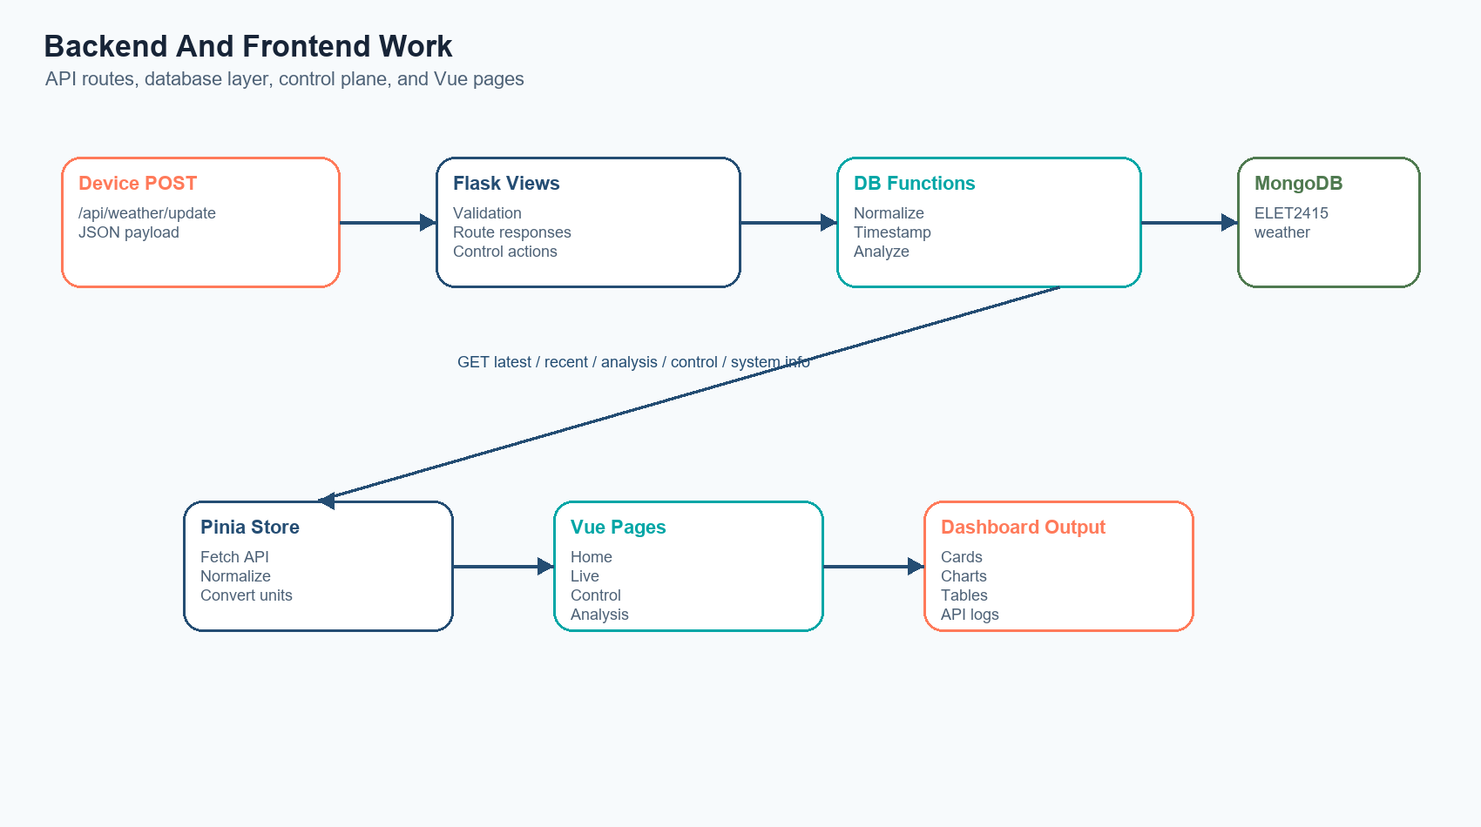
Generated backend and frontend flow diagram
POST /api/weather/update performs this sequence:
- Parse JSON body.
- Check required fields id and type.
- Confirm type equals weather.
- Confirm optional sensor fields are numeric if present.
- Normalize values into strings, floats, integers, and boolean flags.
- Add backend UTC timestamp.
- Insert document into MongoDB.
- Attempt MQTT publish to the configured topic.
- Return save result metadata to the device.

10.5 MongoDB Storage
Default backend database configuration:
Variable | Default
MONGO_HOST | localhost
MONGO_PORT | 27017
MONGO_DB | ELET2415
MONGO_COLLECTION | weather

Stored weather documents include the device ID, payload type, timestamp, present sensor values, and health flags.

10.6 Backend Analysis Work
The backend computes analysis for:
- temperature
- humidity
- heat index
- pressure
- altitude
- soil moisture percentage
The analysis route returns:
- count of documents in range
- start and end timestamps
- min, max, and average per metric
- sampled readings for charting
- recent rows for tables

10.7 Backend Control Work
The backend control plane tracks:
- maintenance mode
- last alert acknowledgement
- pending command queue
- recent command history
- delivery mode metadata
- latest weather snapshot metadata
Supported control actions:
- enable-maintenance
- disable-maintenance
- acknowledge-alerts
- queue-gateway-refresh
- queue-gateway-restart
- queue-sensor-restart
- clear-pending-commands
Important limitation:
- control actions are backend-tracked only in this repository; the firmware does not currently pull and execute queued commands.

11. Frontend Work

11.1 Frontend Purpose
The frontend is a Vue/Vuetify browser dashboard that displays the current state of the weather station, recent trends, control status, and date-range analysis.

11.2 Frontend Stack
Package | Purpose
Vue 3 | UI framework
Vue Router | Page routing
Pinia | Shared state store
Vuetify | UI components
Vite | Development server and build tool
@mdi/font | Icon font dependency

11.3 Frontend Source Files
File | Role
frontend/src/App.vue | App shell and navigation
frontend/src/router/index.js | Route map
frontend/src/store/weather.js | API calls, state, formatting, unit conversion
frontend/src/views/WeatherDashboard.vue | Main dashboard
frontend/src/views/WeatherLive.vue | Live sensor charts
frontend/src/views/WeatherControl.vue | Control and system status
frontend/src/views/WeatherAnalysis.vue | Date-range analysis

11.4 Route Map
Route | Purpose
/home | Main dashboard
/live/:sensor | Sensor-specific recent trend view
/control | Gateway/system operations view
/analysis/:sensor | Date-range analysis view
/ | Redirects to /home

11.5 Dashboard View
The dashboard displays:
- latest reading freshness
- last update time
- reading age
- temperature, humidity, heat index, pressure, altitude, and soil moisture cards
- trend direction versus prior reading
- sensor fallback status
- recent history charts
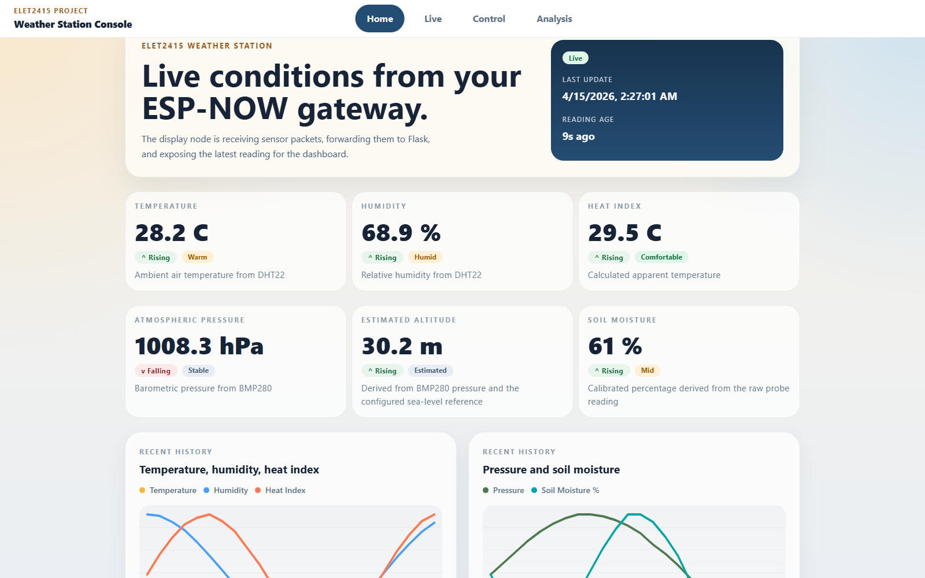
Frontend dashboard screenshot

11.6 Live View
The live view presents recent-history chart pages for:
- temperature
- humidity
- heat index
- pressure
- altitude
- soil moisture
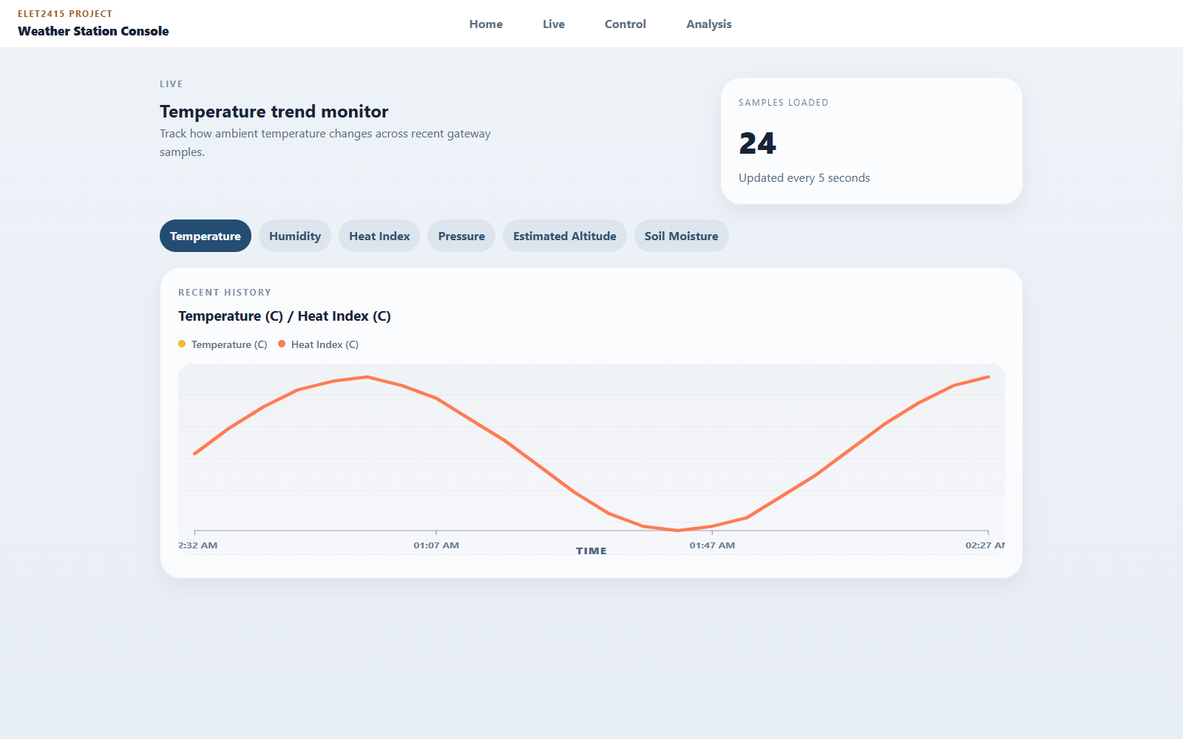
Frontend live screenshot

11.7 Control View
The control page displays:
- gateway health
- maintenance mode
- queued commands
- latest backend reading time
- unit system toggle
- pending commands
- recent control activity
- MongoDB configuration
- schema metadata
- frontend API log entries
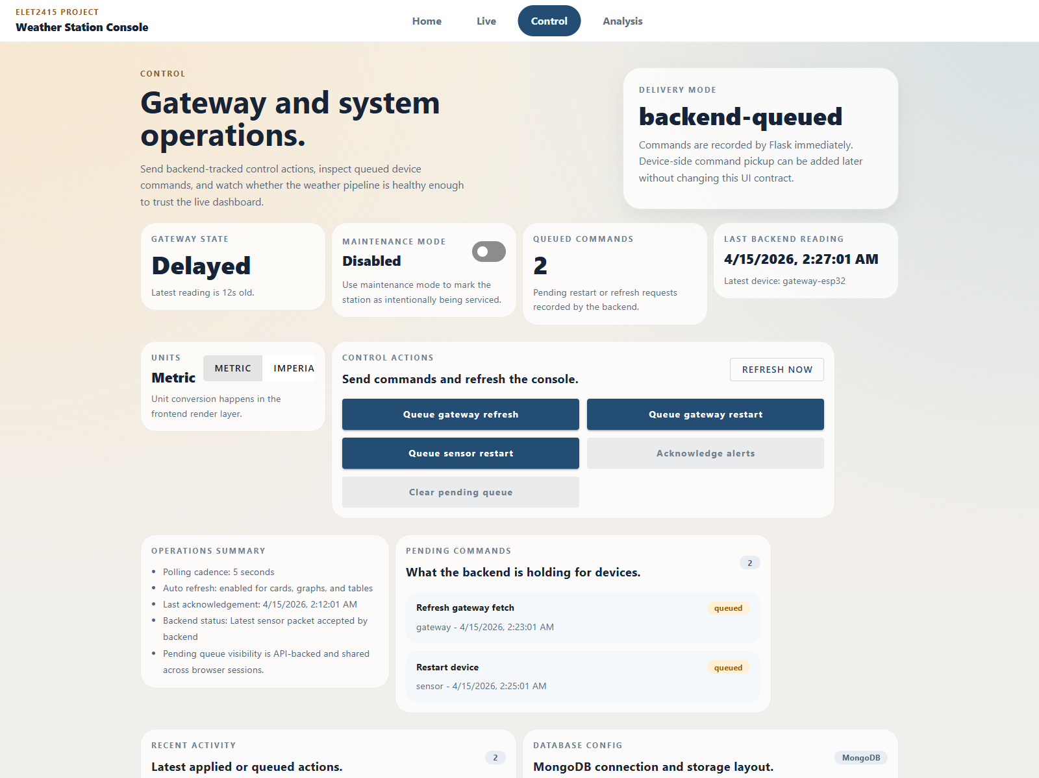
Frontend control screenshot

11.8 Analysis View
The analysis page supports:
- selectable start and end date range
- metric-specific analysis
- min, average, and max display
- sampled chart readings
- recent rows from the selected time range
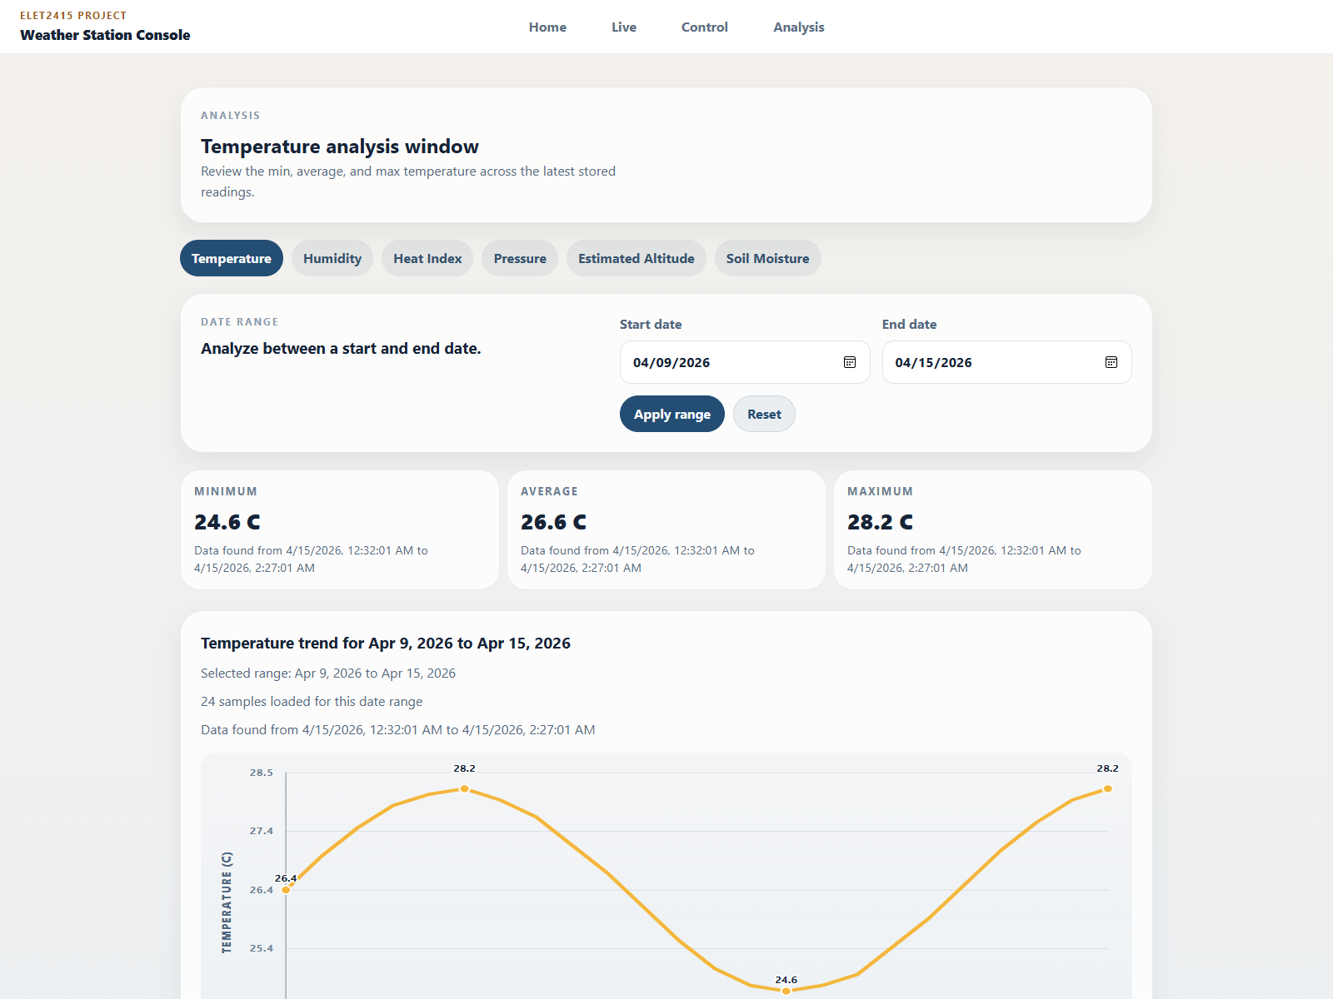
Frontend analysis screenshot

11.9 Unit Conversion
The frontend supports metric and imperial rendering. Data is stored in the backend in the same normalized units, and display conversion happens in the frontend layer.
Conversions:
- Celsius to Fahrenheit
- hPa to inHg
- meters to feet

12. Data Model And API Reference

12.1 Weather JSON Example
{
"id": "620169874",
"type": "weather",
"temperature": 24.6,
"humidity": 53.1,
"heatIndex": 24.5,
"pressure": 932.9,
"altitude": 691.8,
"seaLevelPressureHpa": 1013.25,
"altitudeEstimated": 1,
"soilMoisture": 372,
"soilRaw": 372,
"soilMoisturePercent": 62,
"dhtOk": 1,
"bmpOk": 1,
"soilOk": 1,
"sampleMillis": 182340
}

12.2 Stored Schema Fields
Field | Type | Required | Source
id | string | Yes | Device
type | string | Yes | Device
temperature | float | No | DHT22
humidity | float | No | DHT22
heatIndex | float | No | Firmware calculation
pressure | float | No | BMP280
altitude | float | No | Firmware estimate
soilMoisture | int | No | Device payload
seaLevelPressureHpa | float | No | Firmware constant
altitudeEstimated | bool | No | Firmware flag
soilRaw | int | No | Device payload
soilMoisturePercent | int | No | Firmware calculation
dhtOk | bool | No | Firmware health flag
bmpOk | bool | No | Firmware health flag
soilOk | bool | No | Firmware health flag
sampleMillis | int | No | Device runtime
timestamp | int | Yes | Backend

12.3 API Routes
Method | Path | Purpose
GET | /api/health | Confirm backend is running
POST | /api/weather/update | Submit weather reading
GET | /api/weather/latest | Return latest stored reading
GET | /api/weather/recent?limit=50 | Return recent readings
GET | /api/weather/analysis | Return stats and sampled range data
GET | /api/control/status | Return control-plane status
POST | /api/control/action | Submit backend control action
GET | /api/system/info | Return database, schema, and route metadata

13. Software And Hardware Diagrams

13.1 Software Flow Diagram
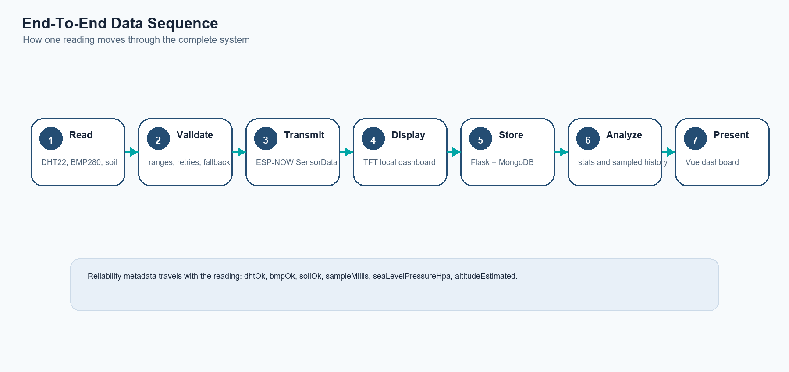
Generated end-to-end data sequence diagram
Sensor firmware
-> read DHT22, BMP280, soil sensor
-> validate ranges
-> smooth values
-> apply fallback if needed
-> build SensorData
-> send ESP-NOW packet
Gateway firmware
-> receive SensorData
-> update TFT display
-> evaluate NORMAL/WARNING/CRITICAL/PARTIAL
-> connect Wi-Fi
-> POST JSON to Flask
Backend software
-> validate JSON
-> normalize data types
-> add timestamp
-> save to MongoDB
-> publish to MQTT topic if available
-> expose latest, recent, analysis, control, and system routes
Frontend software
-> poll backend every 5 seconds
-> normalize readings
-> convert units for display
-> render dashboard, live charts, control, and analysis pages

13.2 Backend Process Diagram
flowchart TD
A[HTTP request /api/weather/update] --> B[Parse JSON]
B --> C[Validate id and type]
C --> D[Validate optional numeric fields]
D --> E[Normalize payload]
E --> F[Add backend timestamp]
F --> G[Insert into MongoDB]
G --> H[Attempt MQTT publish]
H --> I[Return API response]

13.3 Sequence Diagram
sequenceDiagram
participant S as Sensor Node
participant G as Gateway Node
participant B as Flask Backend
participant M as MongoDB
participant F as Frontend
S->>S: Read and validate sensors
S->>G: Send SensorData over ESP-NOW
G->>G: Update TFT display
G->>B: POST /api/weather/update
B->>B: Validate and normalize payload
B->>M: Insert weather document
B-->>G: Return save response
F->>B: Poll latest, recent, analysis, control
B->>M: Query documents
B-->>F: Return JSON data

13.4 Frontend Page Diagram
App.vue
|
+-- /home
| +-- WeatherDashboard.vue
|
+-- /live/:sensor
| +-- WeatherLive.vue
|
+-- /control
| +-- WeatherControl.vue
|
+-- /analysis/:sensor
+-- WeatherAnalysis.vue
Shared data and API layer:
frontend/src/store/weather.js

14. Setup And Operation

14.1 Hardware Prerequisites
- ESP32 sensor board
- ESP32 display/gateway board
- DHT22 sensor
- BMP280 sensor
- analog soil moisture sensor
- TFT display
- USB programming cables
- stable power supply

14.2 Software Prerequisites
- Python 3
- Node.js and npm
- MongoDB
- Arduino IDE or arduino-cli
- ESP32 board support package
- Arduino libraries:
- DHT sensor library
- Adafruit BMP280 library
- TFT_eSPI

14.3 Backend Setup
From backend/:
python -m venv .venv
.venv\Scripts\activate
pip install -r requirements.txt
python run.py
The backend listens on 0.0.0.0:5000 by default.

14.4 Frontend Setup
From frontend/:
npm install
npm run dev
The Vite server listens on 0.0.0.0. By default, the frontend calls:
http://<current-browser-host>:5000
Set VITE_API_BASE_URL if the backend runs somewhere else.

14.5 Firmware Configuration Checklist
Before flashing:
- confirm Wi-Fi SSID and password
- confirm backend IP address constants
- confirm device ID
- confirm gateway MAC address for ESP-NOW mode
- confirm ESPNOW_WIFI_CHANNEL is aligned
- confirm TFT_eSPI board setup matches the display hardware
- confirm soil calibration values
- confirm BMP280 I2C address

14.6 Recommended Bring-Up Order
- Start MongoDB.
- Start the Flask backend.
- Verify GET /api/health.
- Start the Vue frontend.
- Open the dashboard in a browser.
- Flash and power the display/gateway board.
- Flash and power the sensor board.
- Watch serial logs on both boards.
- Confirm backend inserts.
- Confirm frontend cards and charts update.

15. Testing And Validation
The repository does not include a formal automated test suite. Validation is currently manual and system-level.

15.1 Backend Validation Checklist
- Start Flask successfully.
- Confirm GET /api/health.
- Submit a known-good POST /api/weather/update.
- Confirm MongoDB insert.
- Confirm GET /api/weather/latest.
- Confirm GET /api/weather/recent.
- Confirm GET /api/weather/analysis.
- Confirm GET /api/system/info.
- Confirm each control action route.

15.2 Frontend Validation Checklist
- Dashboard loads without console-breaking errors.
- Latest reading cards populate.
- Recent charts render.
- Unit toggle changes displayed units.
- Control page loads database and schema metadata.
- Analysis page returns min, average, and max for a chosen date range.

15.3 Sensor Node Validation Checklist
- DHT22 starts and returns in-range values.
- BMP280 initializes at address 0x76 or 0x77.
- Soil sensor raw value is inside the expected ADC range.
- Smoothing produces stable output.
- Fallback messages appear when a sensor is temporarily invalid.
- Sender serial log shows payload activity every loop cycle.

15.4 Gateway Validation Checklist
- Gateway receives ESP-NOW packets.
- Packet age resets on new data.
- TFT display updates correctly.
- Stale status appears if packets stop arriving.
- Backend POST succeeds after packet reception.

15.5 Integration Test Cases
Test | Method | Expected result
End-to-end happy path | Run sensor, gateway, backend, MongoDB, frontend | Reading appears on TFT, backend, and dashboard
Backend unavailable | Power boards while backend is offline | Local logs show HTTP failure; sensing/display continues
DHT failure | Disconnect or destabilize DHT22 | dhtOk false; fallback used if baseline exists
BMP failure | Disconnect BMP280/I2C | bmpOk false; other sensors continue
Soil instability | Disturb or disconnect soil probe | out-of-range protection and fallback behavior
Stale ESP-NOW data | Stop sensor sender | gateway marks packet stale after threshold

16. Results And Project Evidence

16.1 Local Display Evidence
The project folder includes a TFT/display prototype reference image.
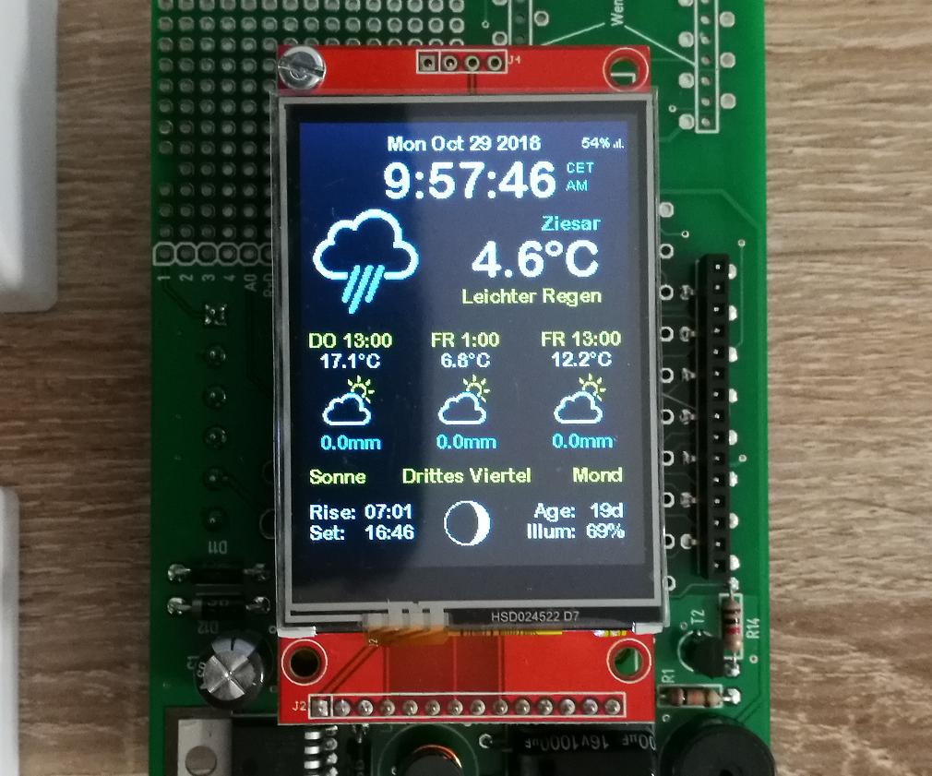
Prototype display photo

16.2 Dashboard Evidence
The frontend screenshots show the dashboard receiving current readings, reporting reading age, and displaying recent trend graphs.

Frontend dashboard screenshot

16.3 Control Page Evidence
The control page demonstrates backend status, queued commands, database metadata, and system operations.

Frontend control screenshot

16.4 Analysis Evidence
The analysis page demonstrates date-range statistics and sampled readings.

Frontend analysis screenshot

16.5 Component Evidence

[Image could not be inserted: ../presentation/assets/images/esp32-board.jpg; ]

[Image could not be inserted: ../presentation/assets/images/dht22.jpg; ]
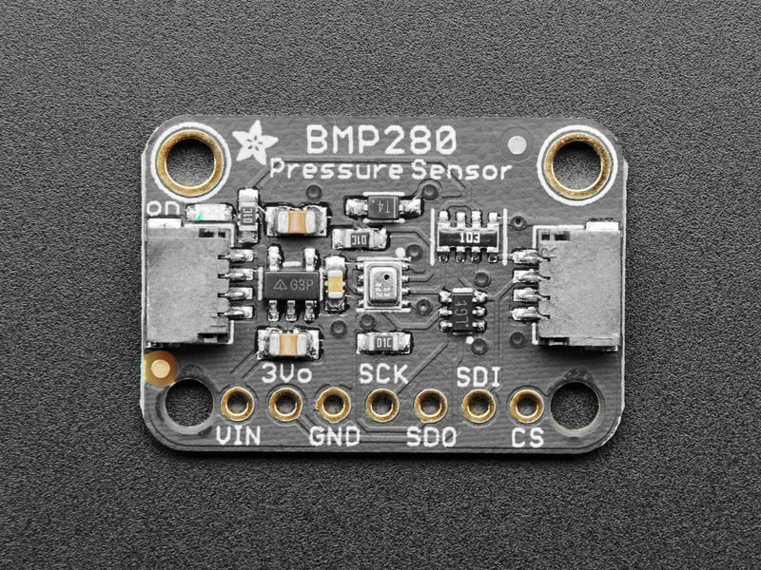
BMP280 sensor
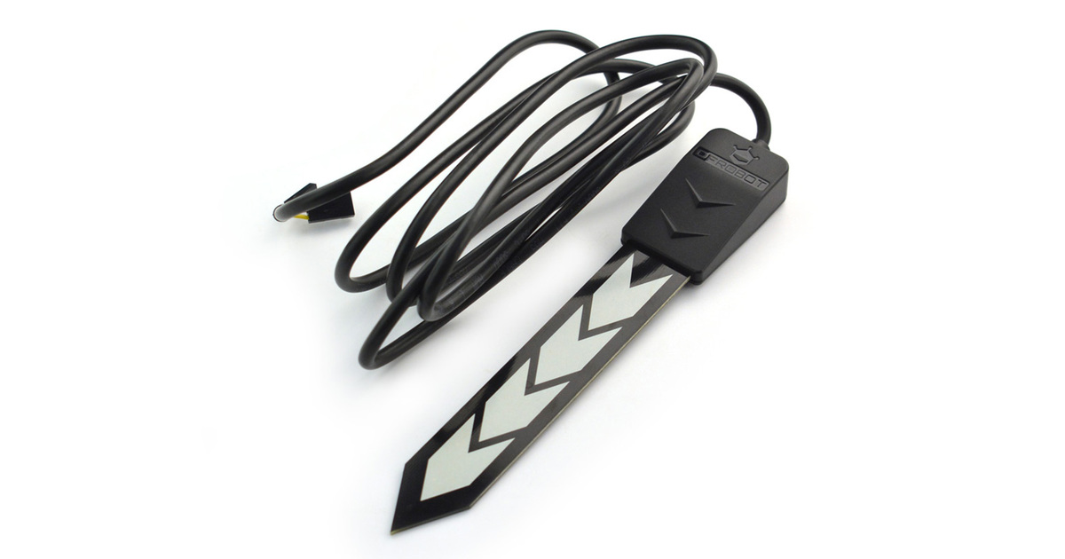
Soil sensor
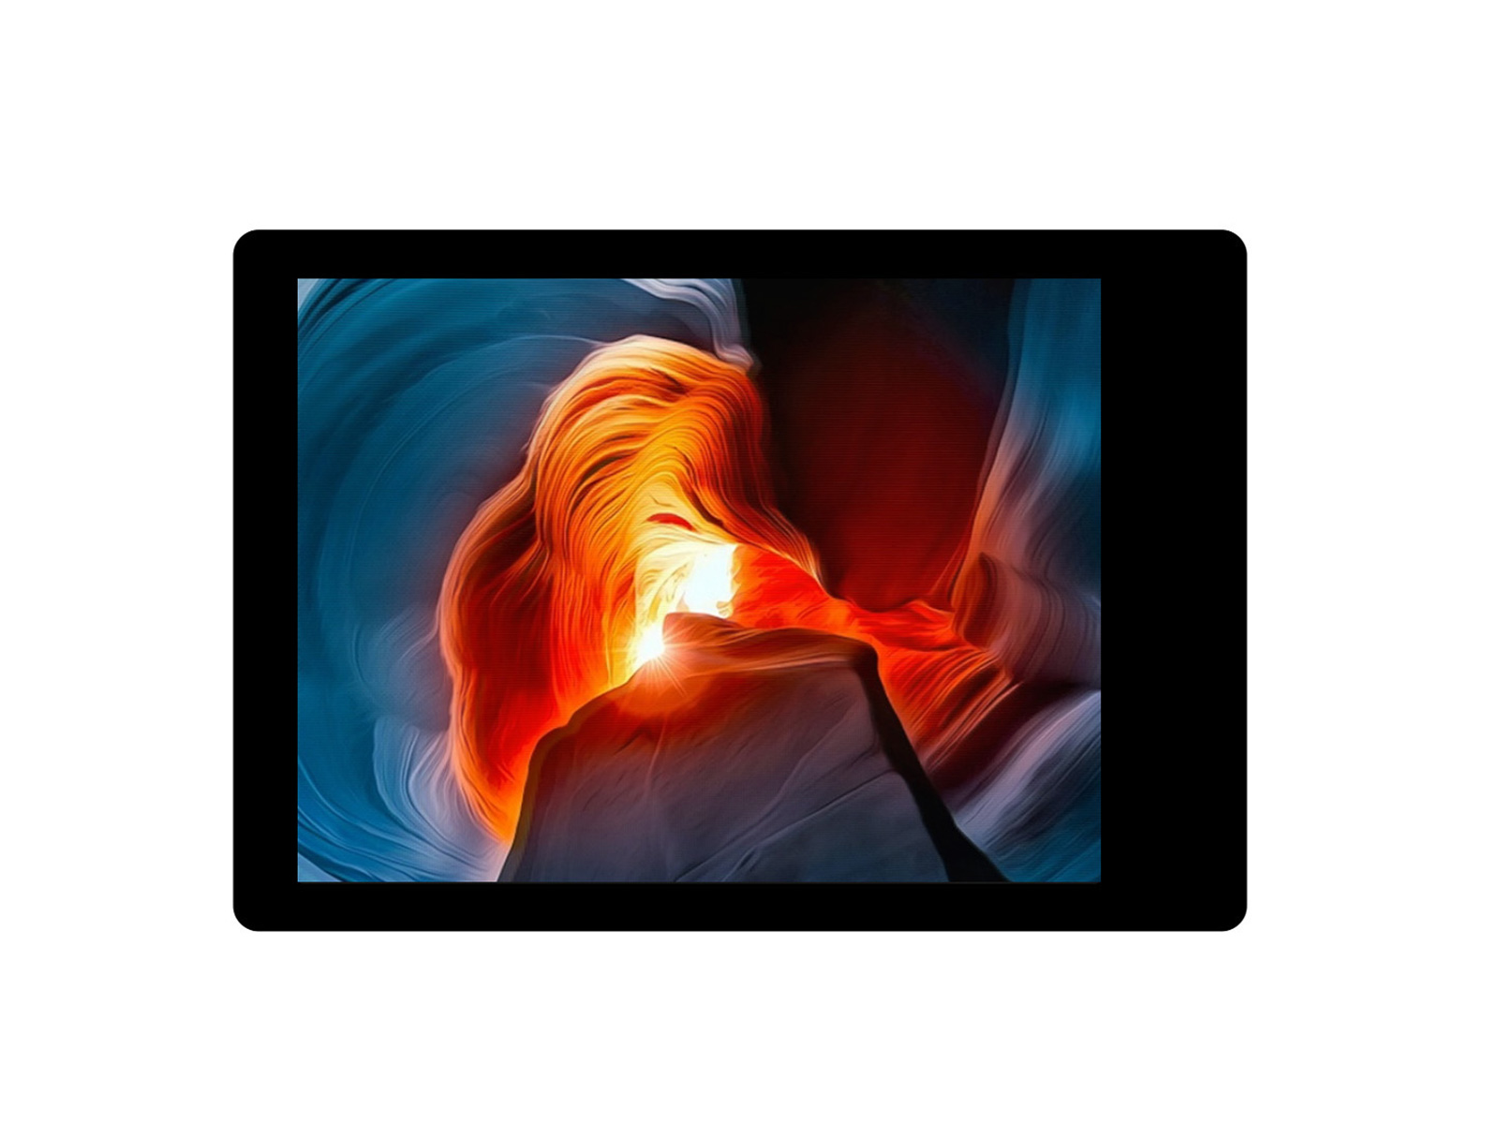
TFT display

17. Troubleshooting, Risks, And Limitations

17.1 Common Troubleshooting
Problem | Likely causes | Checks
Backend does not receive data | Wrong backend IP, backend offline, Wi-Fi issue, port blocked | Confirm Flask, /api/health, firmware IP, serial logs
ESP-NOW packets not arriving | Channel mismatch, wrong peer MAC, Wi-Fi channel conflict | Confirm ESPNOW_WIFI_CHANNEL, MAC addresses, serial logs
BMP280 fails | Wiring, I2C address, power issue | Check SDA/SCL, addresses 0x76 and 0x77, startup logs
DHT22 read failures | Wiring instability, timing sensitivity | Check data line, supply voltage, retry logs
Soil readings wrong | Calibration mismatch, ADC range issue, probe placement | Inspect raw ADC, recalibrate wet/dry constants
TFT display incorrect | TFT_eSPI setup mismatch | Confirm local TFT driver and pin configuration
Frontend stale or empty | No backend data, wrong API base URL, backend query failed | Check API logs and /api/weather/latest
Control actions do not affect devices | Device-side command consumer not implemented | Treat as known current limitation

17.2 Known Risks
- Firmware network settings are hard-coded and must be updated when the Wi-Fi or backend host changes.
- ESP-NOW and Wi-Fi coexistence depends on channel alignment.
- Control state is stored in backend memory and is lost on backend restart.
- The current API has no authentication.
- Soil moisture is relative and probe-dependent.
- Altitude is estimated from pressure and calibration.
- There is no persistent local queue if backend posting fails.

17.3 Current Limitations
- No automated frontend/backend/firmware test suite in the repository.
- No device-side command pickup for queued backend actions.
- No weatherproof enclosure or power-management design.
- No long-duration endurance test results included.
- TFT bus configuration depends on local TFT_eSPI setup outside the repository.

18. Future Improvements
- Add a weatherproof enclosure.
- Add battery or solar power support.
- Persist control state in MongoDB.
- Add device-side polling/execution for queued commands.
- Add backend authentication or LAN access control.
- Add alerting through email, SMS, or push notification.
- Add an automated irrigation actuator.
- Add configuration mode for Wi-Fi and backend address.
- Add automated tests for API routes and frontend store behavior.
- Add long-duration logging and reliability testing.

19. Conclusion
Smarty Weather Station demonstrates a complete IoT monitoring system. It reads multiple environmental sensors, validates and smooths measurements, sends data over ESP-NOW, displays readings locally, forwards data to a Flask backend, stores readings in MongoDB, and visualizes live and historical values in a Vue dashboard.
The project shows integration across hardware, firmware, backend, database, and frontend layers. It also addresses practical engineering concerns such as noisy sensors, partial failures, stale data, backend validation, and user-facing status reporting. The result is a strong project platform that can be extended into smart agriculture, greenhouse monitoring, classroom demonstration, and environmental automation.

20. Appendices

Appendix A: Main Repository Files Used
Path | Use In This Document
README.md | Repository overview
Project Documentation/01-project-overview.md | Project goals and scope
Project Documentation/02-system-architecture.md | Architecture and data lifecycle
Project Documentation/03-hardware-design.md | Components, pin mapping, calibration
Project Documentation/04-firmware-design.md | Firmware structure and behavior
Project Documentation/05-backend-design.md | Backend architecture
Project Documentation/06-frontend-design.md | Frontend architecture
Project Documentation/07-api-reference.md | API routes and schema
Project Documentation/08-setup-and-operation.md | Setup steps
Project Documentation/09-testing-and-validation.md | Validation strategy
Project Documentation/10-troubleshooting-and-risks.md | Troubleshooting and risks
docs/weather-station-report.md | Report draft source
hardware/active/pcb_sensor_test/pcb_sensor_project/pcb_sensor_project.ino | Current sensor firmware constants and behavior
hardware/active/pcb_display_project/pcb_display_project.ino | Current gateway/display firmware constants and behavior
backend/app/views.py | API routes and validation logic
backend/app/functions.py | MongoDB normalization and analysis
frontend/src/store/weather.js | Frontend API, unit conversion, and normalization
frontend/src/views/ | Dashboard, live, control, and analysis UI

Appendix B: Image And Diagram Assets Used
Asset | Purpose
presentation/assets/images/wireless-weather-station.png | System overview visual
presentation/assets/images/weather-station-device.png | Display/device visual
presentation/assets/images/wireless-link.png | Wireless display/gateway concept
presentation/assets/images/weather-station-schematic.jpg | Schematic reference
presentation/assets/images/esp32-dht-bmp-wiring.jpg | DHT22 and BMP280 wiring reference
presentation/assets/images/esp32-soil-dht-wiring.jpg | Soil and DHT wiring reference
presentation/assets/images/frontend-home.png | Dashboard screenshot
presentation/assets/images/frontend-live.png | Live view screenshot
presentation/assets/images/frontend-control.png | Control page screenshot
presentation/assets/images/frontend-analysis.png | Analysis page screenshot
presentation/assets/images/prototype-display-photo.jpg | TFT/display prototype photo
presentation/assets/images/esp32-board.jpg | ESP32 component image
presentation/assets/images/dht22.jpg | DHT22 component image
presentation/assets/images/bmp280.jpg | BMP280 component image
presentation/assets/images/soil-sensor.jpg | Soil sensor component image
presentation/assets/images/tft-display.jpg | TFT display component image
Project Documentation/final-documentation-assets/system-architecture-generated.png | Generated final architecture diagram for submission
Project Documentation/final-documentation-assets/hardware-pinout-generated.png | Generated hardware pinout and interface diagram
Project Documentation/final-documentation-assets/firmware-flow-generated.png | Generated firmware flow diagram
Project Documentation/final-documentation-assets/backend-frontend-flow-generated.png | Generated backend/frontend flow diagram
Project Documentation/final-documentation-assets/data-sequence-generated.png | Generated end-to-end sequence diagram

The project folder also contains SVG diagram assets:
- presentation/assets/images/system-architecture.svg
- presentation/assets/images/wiring-diagram.svg
- presentation/assets/images/schematic-overview.svg
- presentation/assets/images/espnow-flow.svg
- presentation/assets/images/backend-flow.svg
- presentation/assets/images/data-flow-animated.svg

Appendix C: Backend Environment Variables
FLASK_HOST=0.0.0.0
FLASK_PORT=5000
FLASK_DEBUG=true
MONGO_HOST=localhost
MONGO_PORT=27017
MONGO_DB=ELET2415
MONGO_COLLECTION=weather
MQTT_BROKER=localhost
MQTT_PORT=1883
MQTT_TOPIC=weatherstation/update

Appendix D: Submission Notes
- This document is based only on project-folder resources and current source code.
- BOM costs are estimated from representative online component listings checked on April 24, 2026, and they exclude shipping and tax.
- The document describes the PCB split system as the main submission architecture because it matches the active PCB sensor and display sketches.
- Some image assets are project visuals, screenshots, references, or presentation graphics. Actual assessment photos can be added later if more project-build photos are captured.

